**Personas:**

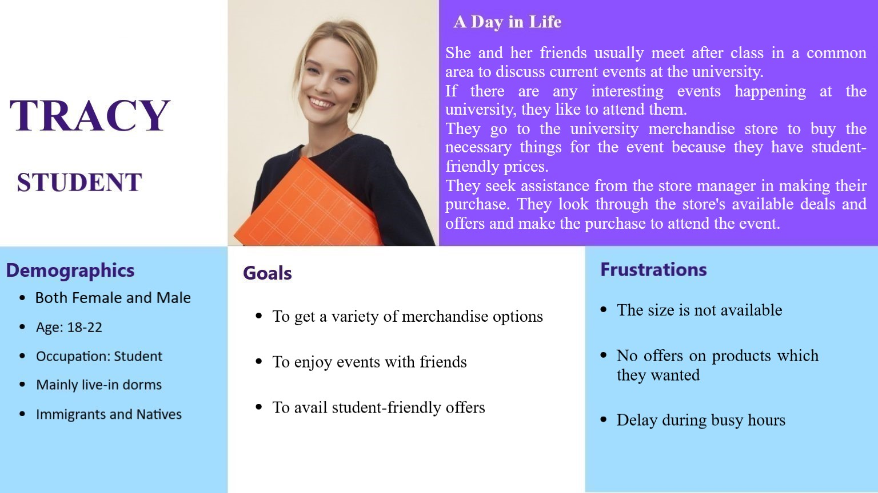

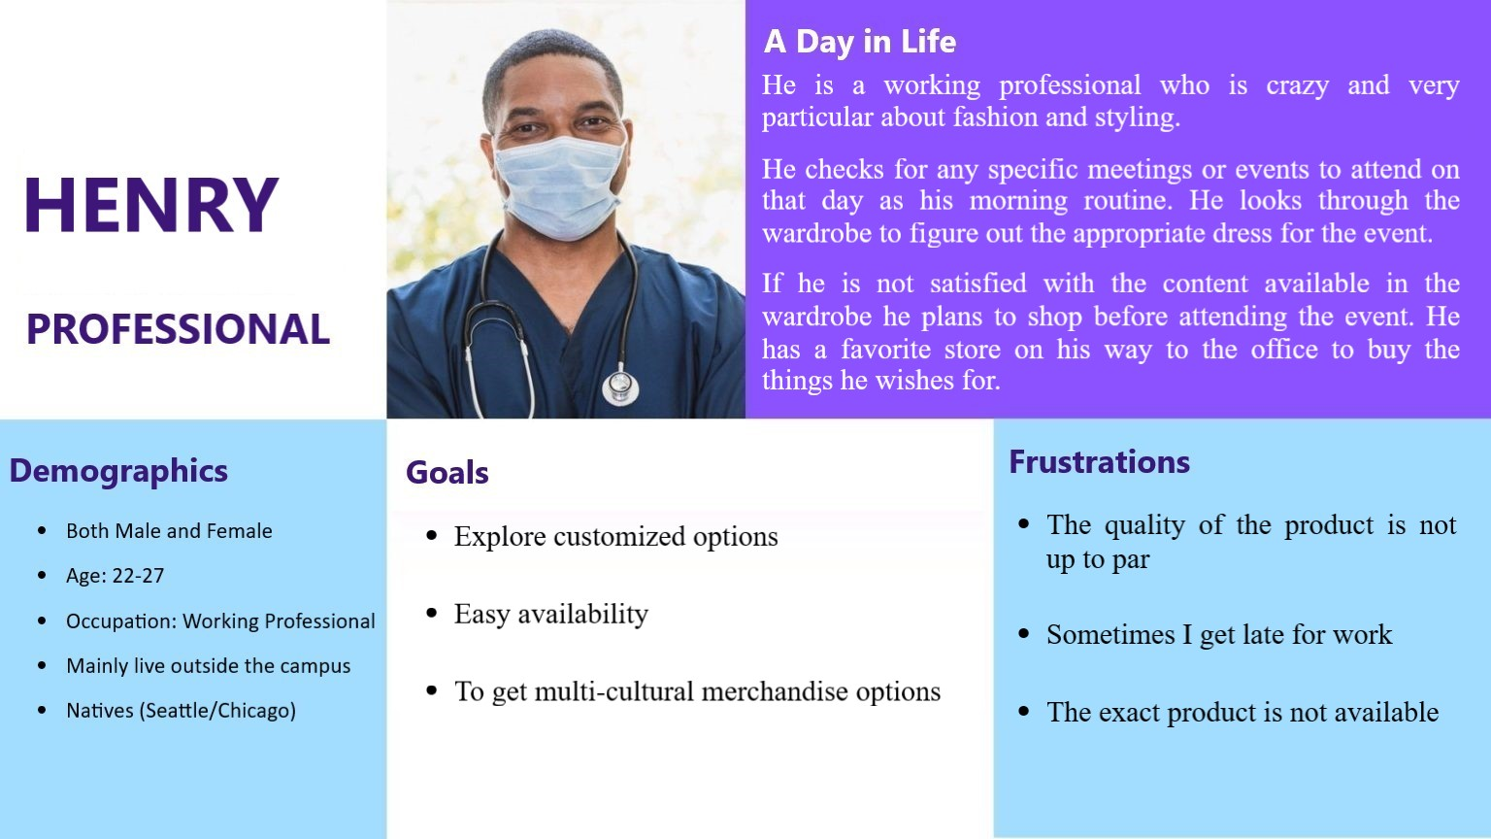

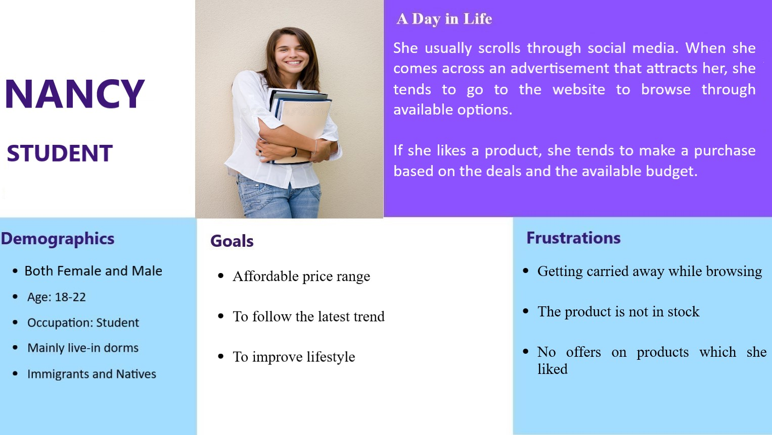

**Key User Tasks**

User key tasks 1:

(user wants: to buy the product)

1. Find their required product in the catalog:

Most people try to find the wished product in the available catalog when they visit any merchandise store

1. To satisfy the needs

Most of the events occurring require a specific kind of attire which is mandatory, so people try to get their hands on that specific product at the store.

1. Browsing through the available catalog

They try to find the specific product by searching the available catalog by modifying the filters.

User key tasks 2:

(user wants: only wants to buy the specific product)

1. Explore different kinds of products

People tend to have different kinds of clothing preferences varying due to differences in the culture

1. To adapt to their desired lifestyle

People define their lifestyle based on influence from the family, social media

1. Explore filter options

They achieve finding their preferred clothing by using the different options of filters such as size, material, color, brand

User key task 3:

(user wants: to find a product in their budget range)

1. Find clothing in an appropriate budget range

People generally tend to have a specific budget range, which varies based on several factors.

1. To plan their expenditure wisely

People try to spend money by prioritizing their needs and wants

1. Setting an appropriate budget using filters

They set their desired budget on the website using filters to sort items in that specific price range.

**Scenarios**

**1. Out of stock**

User:

Natasha is a student at UIC. She along with her friends plans on attending a rugby match to support UIC during the weekend wearing team t-shirt. But when they visit the university merchandise store, the product is out of stock and they are disappointed.

User Needs:

* Product availability
* Wait Time reduction
* Satisfaction
* Easy usability

Scenario:

“Natasha usually goes to the store to buy university merchandise. Her university was hosting a major sporting event right around the corner. She along with her friends planned to attend the event wearing their favorite team t-shirt. The shirts were out of stock when they arrived at the store to purchase them before the match. The benefit of using our app is that you may pre-order the items you need days ahead of time, and the retailer will ensure that they have enough stock to meet the demand based on online orders and in-store sales. She and her friends may simply pre-order the t-shirts well in advance of the event and pick them up right before the event. The application is easy to use.”

**2. Filtering**

User:

John is a student who is a perfectionist and likes to have everything according to his taste and interest which vary widely.

User Needs:

* Easy filtering
* Quick purchase of the preferred product
* Availability of multiple filter tools

Scenario:

“John has a habit of browsing through a variety of options before making a final decision on a product. Whenever he visits any store, he looks for the options provided for all the available items in the store and makes an informative order. Whenever he visits a store, it takes up a lot of time to browse through the available catalog. In our application, John can filter through various options such as (size, price range, delivery preferences) at one glance. Through making the appropriate filter selections, John spectates at the available options and makes a purchase.”

**3. Deals and Offers**

User:

“Alan is a new student who would like to get information regarding the available deals and offers at the university merchandise store.”

User Needs:

* Available offers at the store
* Receives mail when deals are updated at the store

Scenario:

“Alan is a new student who would like to know about the available deals and offers at the university merchandise store. He has to visit the store on a daily basis to have up-to-date information regarding the available offers. In our application, the users can subscribe for alerts regarding the deals through the website. Alan subscribes to the alerts regarding the deals through the website. He sees an offer on a pair of shoes he wants and decides to buy them based on the offer. He routinely utilizes the notifications through mail to receive special discounts on his products.”

**Storyboards:**

